Bradley Reardon

Time Series Forecasting and Analysis

HW9

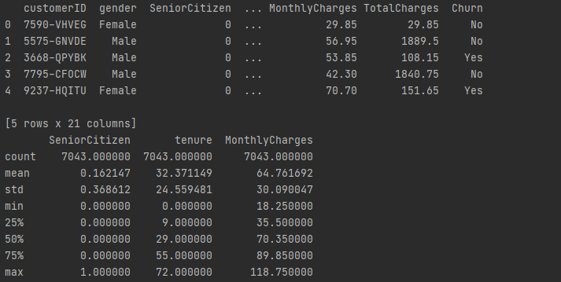

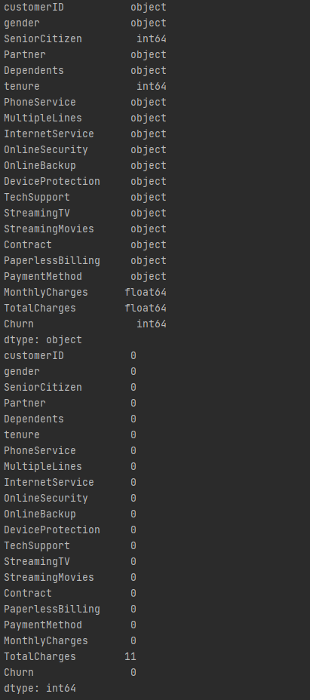

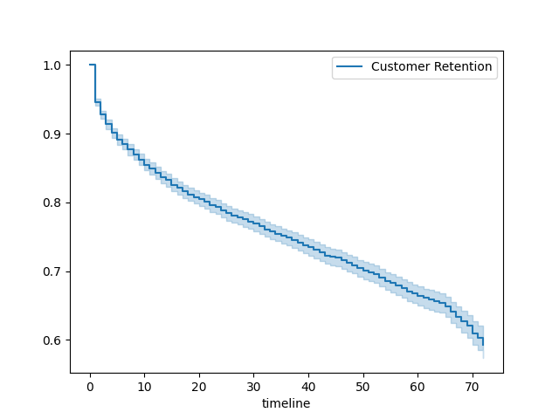

from lifelines import KaplanMeierFitter  
import pandas as pd  
import matplotlib.pyplot as plt  
  
# q 1  
df = pd.read_csv(r'C:\Users\brear\OneDrive\Desktop\Grad School\Time-Series-Analysis-and-Moldeing\Datasets\WA_Fn-UseC_-Telco-Customer-Churn.csv')  
print(df.head())  
print(df.describe())  
  
# q 2  
df['TotalCharges'] = pd.to_numeric(df['TotalCharges'],errors='coerce')  
  
# q 3  
df['Churn'] = df['Churn'].apply(lambda x: 1 if x == 'Yes' else 0)  
  
# q 4  
print(df.dtypes)  
features = df.columns  
for feature in features:  
 if df[feature].dtype == 'object':  
 df[feature].fillna(value=df[f'{feature}'].mode(), inplace=True)  
 elif df[feature].dtype == 'int64' or df[feature].dtype == 'float64' or df[feature].dtype == 'numeric':  
 df[feature].fillna(value=df[f'{feature}'].mode(), inplace=True)  
print(df.isna().sum())  
  
# q 5 - 8  
durations = df['tenure']  
event_observed = df['Churn']  
ax = plt.subplot(111)  
kmf = KaplanMeierFitter()  
kmf.fit(durations, event_observed,label='Customer Retention')  
kmf.plot_survival_function(ax=ax)  
plt.show()